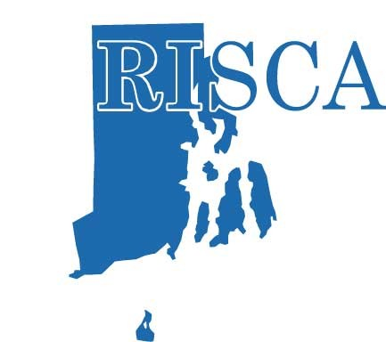

May 2019

Dear Exhibitor/Sponsor,

The Rhode Island School Counselor Association (RISCA), the official state branch of the American School Counselor Association (ASCA), represents professional school counselors, counselor administrators, graduate students, and counselor educators in all academic work settings from elementary through post-secondary, public, private, and technical schools. We would like to offer you an opportunity to showcase your school, product, company, or service with our members. Becoming a sponsor will provide your organization with more options for promotion as well as allowing RISCA to continue to offer a premier professional development experience for counselors.

Our Fall Conference will be held on October 23, 2019 at the Crowne Plaza Hotel in Warwick.

We would love to have you as one of our Sponsors or Exhibitors! Registration materials are attached. Please complete the Sponsorship Form and return it by September 27, 2019

On behalf of RISCA, we thank you for your partnership and support!

Sincerely,
Lisa Tenreiro

RISCA President Elect
Fall Conference Co-Chairperson

RISCA Exhibitor Prices & Sponsor Packages | Fall 2019  Conference  Contributions
Gold Level –  One exhibit table at event (breakfast included)  Full page ad in conference program booklet  Material put in attendee’s bag (if provided)  List and contact information for all attendees  Your company name and logo on display at conference  Listing on website & in program as Gold Sponsor | $1000
Silver Level –  One exhibit table at event (breakfast included)  Half page ad in conference program booklet  Material put in attendee’s bag (if provided)  Your company name and logo on display at conference  Listing on website & in booklet as a Silver Sponsor | $700
Bronze Level –  One exhibit table at event (breakfast included)  Half page ad in conference program booklet  Your company name and logo on display at conference | $300
Full Page Ad (Conference Program Booklet)  (Please submit Ads by September 18th deadline) | $125
Conference Material Donations (ie folders, tote bags, notebooks, flash drives, pens, favors)  (listed in program as official donor of)  (Please submit by October 11) | No Cost
Official Breakfast Sponsor (includes sign) – will be given to first one who submits payment & will be included in Booklet | $500
Official Coffee/Snack Break Sponsor (includes sign) – will be given to first one who submits payment & will be included in Booklet | $500
Exhibit Table Only | $100

Participation as an exhibitor at a RISCA conference does not imply any RISCA affiliation or endorsement of products or services

RISCA Sponsor/Exhibitor Enrollment and Agreement
Registration Form for 2019 Fall Conference

Deadline is: September 27, 2019

Name of Business/School/Organization: ____________________________________________________________

Address: _____________________________________________________________________________________

Contact Person & Title: _________________________________________________________________________

Email: ______________________________________ Work Phone: _______________________________

School/Company Website: ______________________________________________________________________

Name and Email of Conference Representative ______________________________________________________

____________________________________________________________ Cell Phone: ______________________

Fee Tallys (check all that apply)

[ ] Gold Sponsor $_____________

[ ] Silver Sponsor $_____________

[ ] Bronze Sponsor $_____________

[ ] Full Page Ad in Conference Program Booklet $ _____________

[ ] Donation N/C

[ ] Official Breakfast Sponsor $ _____________

[ ] Official Coffee Break sponsor. $ _____________

[ ] Exhibit Table Only $_____________

Total Amount $ _____________
Make Check Payable to RISCA
Email any questions to riscapresident@gmail.com

Agreement Terms and Conditions
- Full payment must accompany application.
- The Exhibit fee enclosed is non-refundable except in the instance where space is unavailable or the event is canceled.
- RISCA reserves the right to refuse to sell exhibit space to any company it deems objectionable or at cross-purposes to the association’s mission.
- Additionally, RISCA reserves the right to require exhibitors to remove promotional material from the show that are deemed objectionable.

Signature: _______________________________________ Title ______________________ Date ___________________

Mail with payment to:
Barbara DiSaia, RISCA
94 Red Hawk Drive
Cranston, RI 02921

